Project Design Phase
Solution Architecture
Date | 01 September 2026
Project Type | Individual Project
Project Name | Software Installation Request Automation in ServiceNow Using Service Catalog and Workflows
Maximum Marks | 4 Marks

Solution Architecture:
The architecture below bridges the business problem (unstructured, manual software installation requests) with the ServiceNow technology solution — describing the structure, flow, and responsibilities of each component from request submission through to fulfillment or exception handling, and how configuration is migrated between instances.
Architecture Diagram:
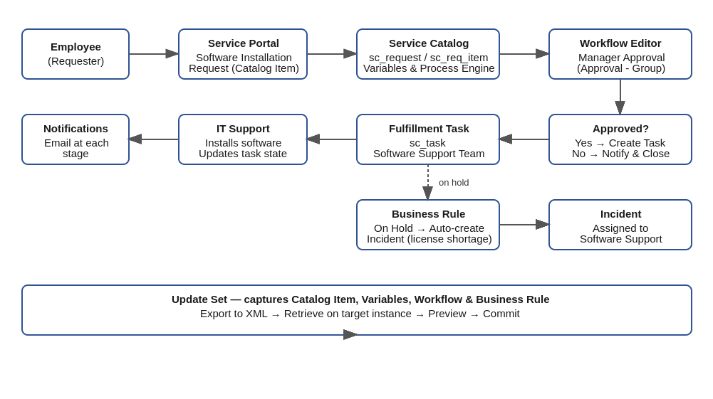
Figure 1: Solution architecture — Software Installation Request Automation in ServiceNow

Component Flow Description:
1. Employee (Requester) opens the Service Portal and submits a Software Installation Request via the Service Catalog item, filling variables for Software Name, Version, License Justification, and Urgency.
2. The Service Catalog creates a Request (sc_request) and Requested Item (sc_req_item), triggering the linked Workflow via the Process Engine.
3. The Workflow routes the request to Manager Approval (Approval - Group activity).
4. On approval, a Fulfillment Task (sc_task) is auto-created and assigned to the Software Support Team; on rejection, the requester is notified and the request is closed.
5. IT Support installs the software and updates the task state (Open → Work in Progress → Completed); notifications are sent to the requester at each stage.
6. If the Requested Item state changes to 'On Hold' (e.g., license shortage), a Business Rule automatically creates an Incident assigned to Software Support, ensuring no blocked request goes untracked.
7. All configuration — the catalog item, variables, workflow, and business rule — is captured in an Update Set, which is exported to XML, retrieved on the target instance, previewed, and committed for clean migration across environments.

